Content for Introductory LANDING Pages

1)

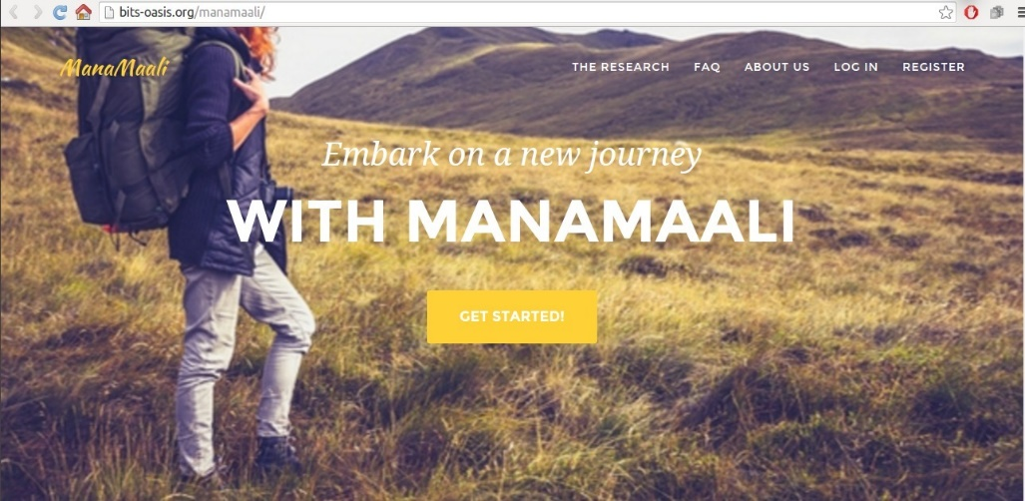

The current image and text are good. On the top right where it says Mana Maali in yellow, you could add: Mana Maali- ‘Gardener of the mind’

After they click on get started, they could find this text welcoming them to the program:

Dear [INSERT STUDENT NAME], by signing up for this program you have taken the first step towards cultivating a healthy mind. This program is designed to help you become more aware of yourself – your thoughts, emotions and behaviors – and equip you with skills and techniques that will help you manage your stress, anxiety and emotions.

2)

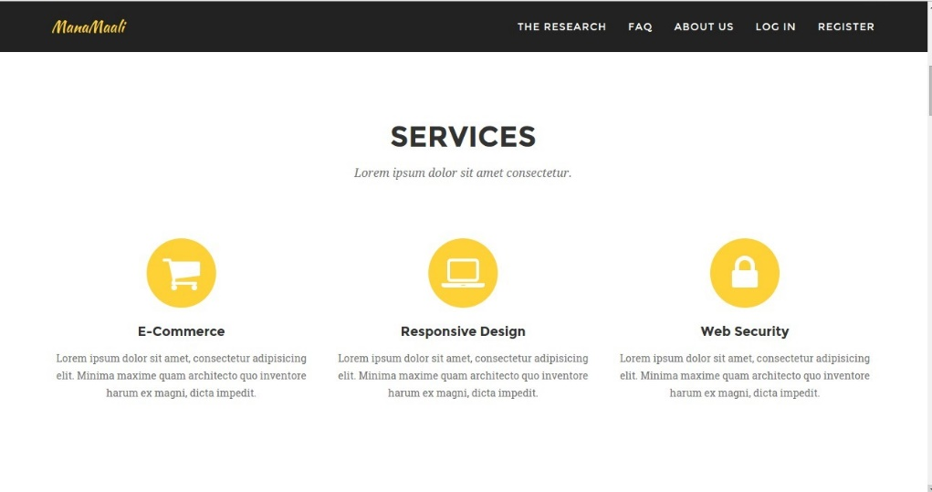

[PLEASE PROVIDE FEEDBACK]

1. Customized journey roadmap

Based on your answers to a few questions, you will receive a customized plan to learn tools and techniques that address your specific concerns.

1. Option to work with a coach

You can opt for a more personalized experience by choosing to work directly with a coach (mental health professional) who will guide you through the program and provide iterative feedback and ongoing support.

1. Toolbox of Mental Wellness Activities

Throughout your journey, you will collect an array of exercises and techniques that help you more productively manage your thoughts, feelings, and emotions.

3)

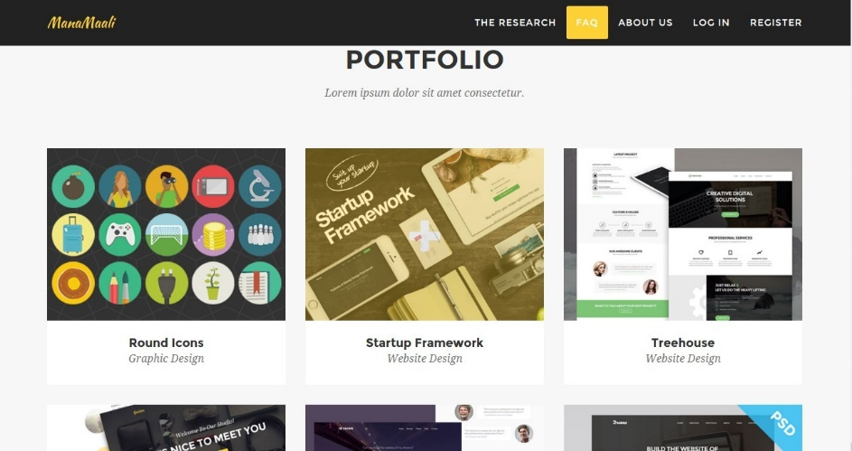

Here we can explain more about the program, each image when clicked could lead to the following information:

Replace “PORTFOLIO” with “HOW IT ALL WORKS”

EACH OF THE BELOW TITLES COULD APPEAR ON TOP OF AN IMAGE AND UPON CLICKING OR SCROLLING OVER THE IMAGE/TEXT, THE FOLLOWING INFORMATION COULD POP UP AS A POP UP TEXT BOX

1. What is Mental Health?

The [World Health Organization (WHO) defines mental health](http://www.who.int/features/factfiles/mental_health/en/) as *a state of wellbeing in which every individual realizes his or her own potential, can cope with the normal stresses of life, can work productively and fruitfully, and is able to make a contribution to her or his community*.

The above definition suggests that if something is preventing you from realizing your potential or functioning optimally, or if you are having difficulty dealing with everyday life stress, or if you are unable to contribute fruitfully to your life or to significant others or society, then you might lack optimal mental health/well-being.

Young people’s mental health includes:

* emotional well-being (e.g., happiness, stability and confidence)
* psychological well-being (e.g., resilience, flexibility, autonomy, sense of mastery)
* social well-being (e.g., interpersonal relationships and citizenship)

*While most of these skills or traits can be achieved through your own efforts or from the support of others (peers, teachers, friends, family members), a few among these might need professional help to fully realize. If you lack a support system, feel helpless, or simply do not feel comfortable discussing such issues with others, it is important that you seek help without hesitation so that time is not lost and future, potentially more severe problems can be averted (prevention is typically better than finding a cure).*

**\*INSERT VIDEO CLIP HERE: (Mana maali mp4)** This video shows students’ common understanding of mental health problems and ways of handling them either by oneself or by seeking help from others.

2. **How do we identify common mental health problems?**

Depression and Anxiety are common mental health problems. The symptoms of depression and anxiety, such as poor concentration, worry, insomnia, and crying spells, are sometimes perceived as minor stresses, but they can actually cause significant distress if left unaddressed. Timely treatment and support for persons suffering from depression and/or anxiety can prevent these symptoms from affecting their daily functioning and causing further distress.

**Depression:** It is OK to feel sad or upset over some unhappy events or circumstances. However, if this feeling persists for a long time (more than two weeks) or recurs frequently and disrupts normal life and health, then it could be a sign of what people call clinical depression. If it is so severe that it is interrupting normal routine, it is commonly addressed with psychological treatment. Depression is a common mental disorder with a set of symptoms that affect a person's thoughts, feelings, behavior, relationships, performance at work and, in very severe cases, may also lead to thoughts of worthlessness and suicide.

[***Click here***](http://www.whiteswanfoundation.org/slideshow/signs-of-depression/) ***to learn more about the signs of depression from our partners at White Swan Foundation***

**Anxiety:** Experiences of trembling before an exam, sweaty palms before a job interview or feeling of butterflies in the stomach before a public performance are regular anxiety that we all go through. Once the event has happened, we calm down and are able to breathe easier. However, some people experience anxiety or panic attacks for no apparent reason. Others find that their anxiety is interfering with their ability to meet their life goals. If you find it difficult to control your anxiety/worries or if these constant feelings of anxiety affect your ability to go about your daily activities, then it might be a case of an anxiety disorder.

[***Click here***](http://www.whiteswanfoundation.org/disorder/anxiety/) ***to learn more about the differences between regular anxiety and an anxiety disorder.***

3. How does the Mana Maali program help?

* This program has previously helped many college students cope with anxiety/stress and relationship/family issues as well as learn skills to manage unhelpful thinking, improve emotional balance, and increase focus and productivity.
* This program is currently available free of charge. As this program takes shape at your college, there might be costs for additional services like communicating with a mental health coach. For now, it is free to you, paid for by your university, the BITSAA alumni, and other donors who support student mental wellness.
* Among all the students who used this program during the 1st phase, 90% of them said they would recommend this program to their friends and peers.

2. How does the program work?

* The Mana Maali student wellness program is designed to help you learn skills and techniques to cope with the challenges that you face in college life. Based on your results from an initial online survey, you will be offered suggestions and guidance to choose information and activities that are relevant to your specific needs (e.g. anxiety or depression modules).
* This information and activities can be accessed via an online program, accessible via the Web or a mobile phone application.
* The program consists of your personalized modules, each of which are comprised of a number of sessions. You will gain access to future sessions as you complete the first sessions. We recommend creating a habit around how you use the program – for example, completing one 10-minute activity every day when you wake up and practicing that skill during the day – but you can customize it as you wish.
* Each session takes about 10 minutes to complete and contains 3 steps. First, you report your current level of anxiety/stress/depression so you can begin tracking your mood and learn how and why it changes over time. Second, you learn something about the specific problem you are facing or symptom you are experiencing to better understand where it comes from and how to control it. Third, you learn a new skill or new technique designed to help you challenge your problem and work towards a solution (for example, a relaxation activity for stress, a worry tool for anxiety, an activity scheduling and reminder tool for when you are feeling down and need to remind yourself to get outside and be with friends.
* *We encourage you to dedicate 10 minutes every day to “self-care” and using this program. This could become your 10 minutes per day during which you enjoy your 10-minute break from the hustle and bustle, relax, and over time even learn how to manage inevitable future stress, proactively think about how to improve the relationships in your life with people you care about, and generally be happier, healthier, and the gardener of your own mind.*
* A lot of students have previously benefitted from having a program guide work with them as they navigate through the program. Therefore, you will be able to select whether you wish to work on your own or with the support of a guide. Being assigned a coach would be based on/subject to availability of coaches (trained mental health guides).

3. How does coaching in the program work?

* Coaching: If you choose to opt for a program guide or coach, your coach will guide you throughout your journey in this program. Coaches work with students and help them apply the tools and techniques they learn in the program. Your coach will be available to answer any questions you have, clarify doubts, and provide feedback about your progress. You can communicate with the coach via a messaging box within the program and your coach will reply back within 24 hours. You may also have the opportunity to directly chat with your coach over the phone if desired.
* Coaches are trained mental health counselors from India. They have experience working with college students and are therefore able to support students as they work through their journey in this program.
* You can feel free to share with your coach about anything that troubles/distresses you. You could share about a bad day at college or an upcoming presentation that is making you anxious. Your coach is there to help you get through your struggles now as well as learn tools and techniques to get through your future struggles on your own.
* In addition to messaging your coach in the program, you have the opportunity to set up a phone call at the beginning, middle, and end of your program. We recommend taking advantage of this option as it is a great way for you and your coach to get to know each and better work together on defining and achieving your goals for using this program.

4. What will you get out of this program?

* You will get out of this program what you put in. Some students have goals like:
  + Reducing anxiety or stress
  + Improving focus/becoming more productive
  + Improve self- confidence
  + Manage emotions better
* The overall aim of this program is to help you be more self-aware and understand where your emotions come from so that you can better control them. Then, the program aims to teach you skills and techniques to manage the inevitable stressors you will face in the future to empower you to be your own mental wellness coach for life.

4)

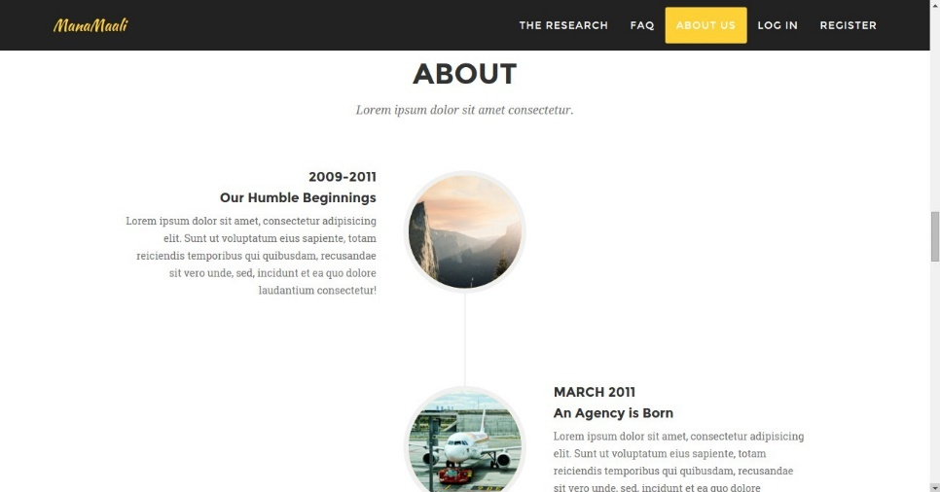

[Review Content]

* The Mana Maali Student Wellness Program launched in 2015 in the BITS Hyderabad Campus and has since expanded to all four BITS campuses in India and Dubai and helped many students work on issues related to anxiety and stress.
* Currently in its third semester, the program aims to address issues such as stigma, limited access to mental health services, and a shortage of mental health professionals that often prevent students from seeking and receiving help. The development of this customized web and mobile phone based platform is an effort to ensure sustainability of the Mana Maali program in BITS and facilitate low-cost expansion to other universities in India.
* To learn more about the initiative, how it started, and those involved, explore the project blog: [**click here**](https://manamaali.wordpress.com/about/)**.**

Timeline:

January 2015- First steps: 1st phase of Mana Maali Student Wellness (Anxiety) Program was initiated at BITS Hyderabad campus and another engineering college in Hyderabad.

October 2015- 2nd phase of Mana Maali Student Wellness Program was introduced across all four BITS campuses (Pilani, Hyderabad, Goa and Dubai)

May 2016- 3rd and on-going phase of Mana Maali Student Wellness Program

5)

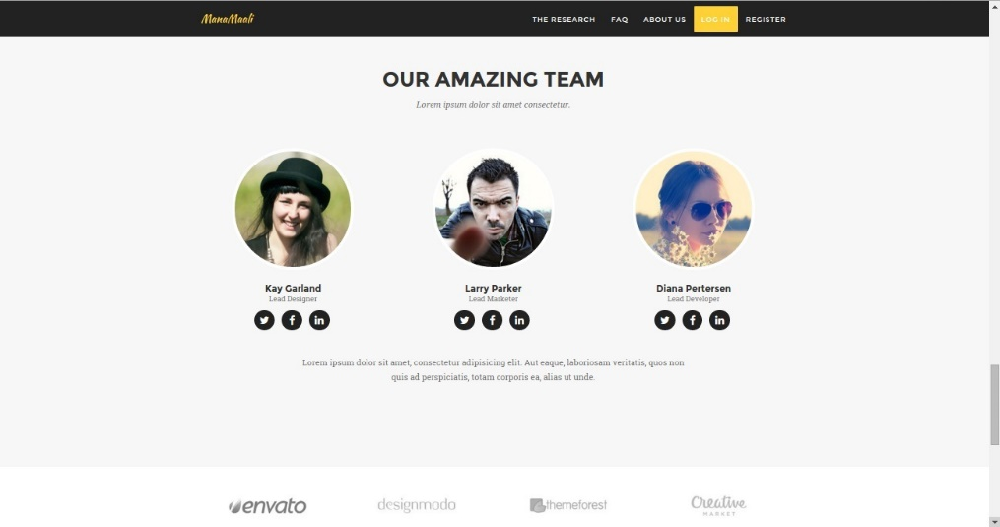

[PLEASE REVIEW]

We should split this section up into a few sections/labels:

Abhimanyu – double check names that Bona fills in for Dev Team and edit as appropriate

1. Software Development Team

* Dr. Banerjee, (ABHIMANYU, PLEASE INSERT RESPECTIVE TITLES/PEOPLE HERE)
* Abhimanyu
* Tarun
* Etc…

1. Content Development Team

* Dr. M. Manjula, Project Investigator, Additional Professor, Clinical Psychology, NIMHANS, Bangalore
* Ms. Bona Colaco, Coach Supervisor, Clinical Psychologist, Mana Maali
* White Swan Foundation
* Insert whoever else wants to be a part of this team (we can also collapse the administration, content, research team categories into one given everyone has multiple roles)

1. Research Team

* Dr. C. Barr Taylor, MD, Project Investigator, Director of Stanford’s Behavioral Medicine Lab
* Dr. Michelle G. Newman, Project Investogator, Director of Penn State’s Lab for Anxiety and Depression.
* Dr. Josef I. Ruzek, Project Investigator, Director, Dissemination and Training, U.S. Department of Veterans Affair.
* Nitya Kanuri, Project Coordinator

1. Coaching Team

* Bona Colaco, Coach Supervisor
* List names of all long-term, active, engaged coaches (if they are interested/willing) – Bona, please discuss with coaches or plan time during next supervision to discuss

1. Student Leadership Team

* Rohan and team (Bona – discuss with Rohan and each campus leadership team to make sure there is an appointed student leader at each campus and they are aware of / approve of this title)

1. Anyone else?

For now, I’d suggest we use these logos:













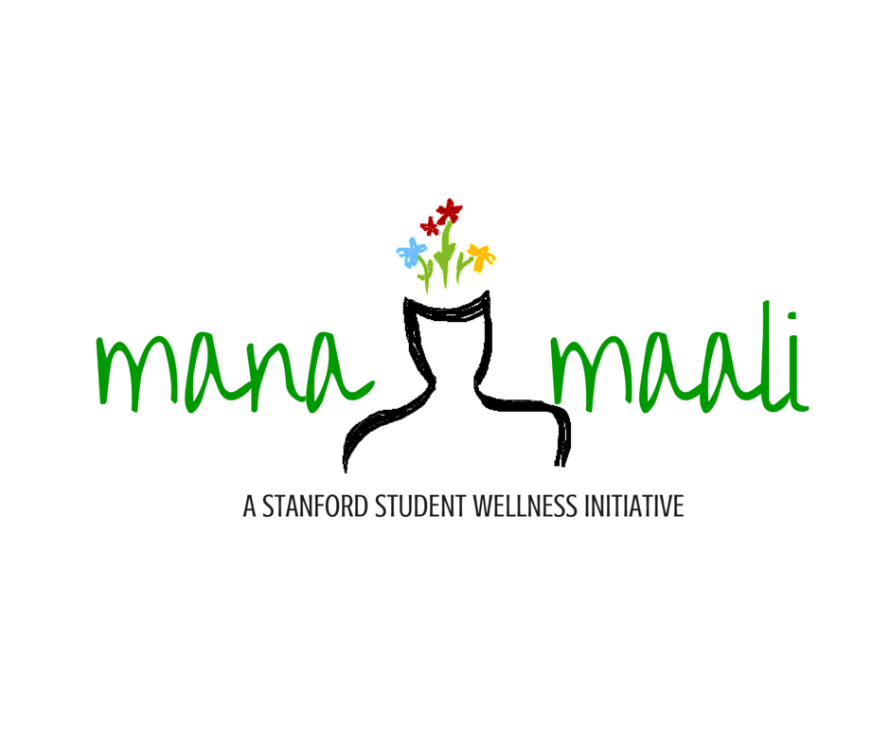

Going forward, we can add profiles of the research team members with an image and brief description.

6)

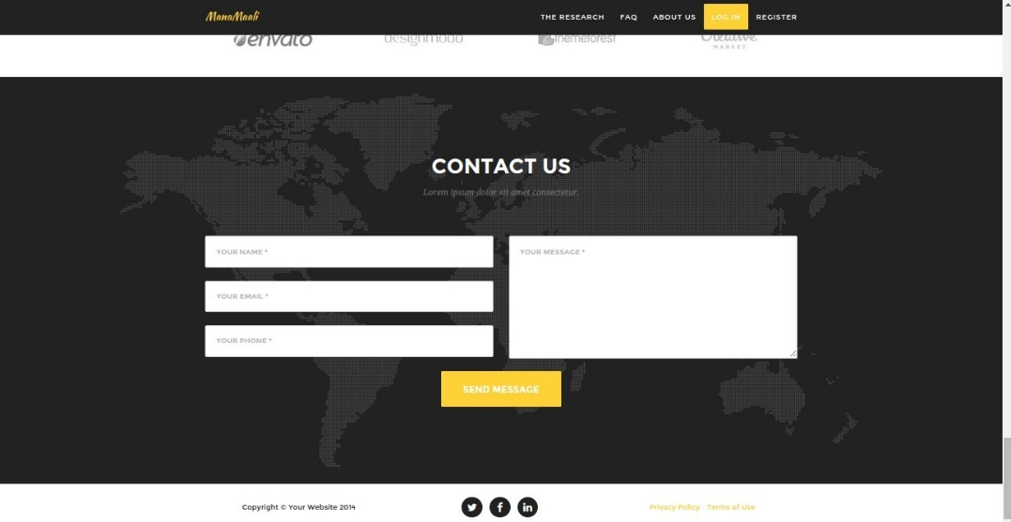

[NITYA PLEASE PROVIDE GUIDANCE ON CREATING THE PRIVACY STATEMENT]

We need two components here: Terms of Use + Privacy Statement

I have created a draft version below that we can use as a placeholder now. I don't know just how “legally binding” it is in India. However, I believe it covers all necessary bases for now and can be used as a placeholder so that Abhimanyu and team can move forward. Given we will be pilot testing with users who are opting in for this testing, we have some time to formalize these details and seek council from local authorities.

Abhimanyu – please look at what others have done here (perhaps other similar sites/apps that you mentioned you have come across or templates that people use/customize) and determine what language is both best but also as minimal as possible

**Terms of Use & Privacy**:

Effective date: June 1st, 2016

Your use of Mana Maali and all its services are subject to the following terms and conditions. If you do not agree with all of the below terms, you may not use the services. Mana Maali nor its stakeholders will be held liable.

Welcome to Mana Maali. Below are the terms and conditions of using any of the Mana Maali services – website, products, applications, etc. These terms are a binding contract between you and Mana Maali, and they must be agreed to prior to use. If you have any questions or doubts, please clarify them before you use any of the services by contacting us at [nkanuri@stanford.edu](mailto:nkanuri@stanford.edu) (placeholder for now).

**Services**: The primary purpose of Mana Maali is to connect university students to more accessible, mental wellness resources, including online content hosted on this website, links to other related websites, mobile applications, and even mental health guides who provide personalized support to students. However, this is not a service to be used in the case of emergencies or crises. This is not a replacement to professional medical care. This is a supplementary service that aims to provide information and education. However, the information learned here, either via the website or via a mental health guide, should not be viewed as a professional medical opinion nor should it inform medical decisions. If you think you have a medical or mental health emergency, please contact local authorities and agencies or go to your nearest hospital. If you are having thoughts of harming yourself, you should immediately notify someone in your network as well as seek professional help.

Any information you learn via using the Mana Maali services or connecting to other third party websites is learned at your own risk. We are not liable for any errors in that content or any future decisions or actions.

**Privacy**: We respect the privacy of those who use our services and we take the utmost care to protect that privacy. You will be required to share certain personal details such as email address so that we can effectively communicate with you in the context of delivering Mana Maali services. We will also monitor and record certain things like your behaviors when using the services (e.g., did you “like” a certain activity) so that we can improve the experience for you later on (e.g., give you that activity again). However, we will only use this information gathered to ensure you have the best experience using these services.

We will also use data gathered on all users to analyze how the services are used IN AGGREGATE so that we can improve the services for current and future users. However, all data will be anonymized and aggregated before any information is disclosed (e.g., 40% of our users rated activity A as “very helpful”).

We will not share your information with any third parties, unless and of course the purpose is to protect you. For example, if disclose that you are having thoughts of harming yourself, we believe it is our duty of respect and care for others to disclose this information to the group of people who have the best ability to help you – your on-campus counselor who might reach out to you and/or your family.

Similarly, we expect you to behave in a respectful manner when interacting with the Mana Maali services. Do not provide fraudulent information, attempt to impersonate others, copy and redistribute copyrighted material, or do anything that would violate local laws. If that occurs, we reserve the right to terminate your use and do not hold liability for your actions.

**Cost of Use**: There is currently no individual fee for using the services of Mana Maali. The services are being supported by stakeholders and committed collaborators (e.g., BITS, BITSAA). This might change later on as the Mana Maali program grows, and we reserve the right to amend such terms of use.

**Termination of Use**: You are free to discontinue use of any of the Mana Maali services at any time. Your information upon termination of use will be treated the same – all privacy standards and protections will remain in place. We reserve the right to terminate your use at any time at our discretion, although it will primarily be driven by a breach in any of these Terms of Use.

**Modification of Terms**: We reserve the right to modify these Terms of use at anytime to improve the services. If you do not agree to the updated Terms, you are free to discontinue use of all Mana Maali services at any time, which is what must happen if you at any point do not agree with and are not willing to abide to the Terms of Use.